**Git and Github**

# What is Git ?

* Git is a version control system for tracking changes in computer files and coordinating work on those files among multiple people.
* It is mainly used for source code management in software development.
* It can be used to keep track of changes in any set of files.
* Versions shown in below figure.

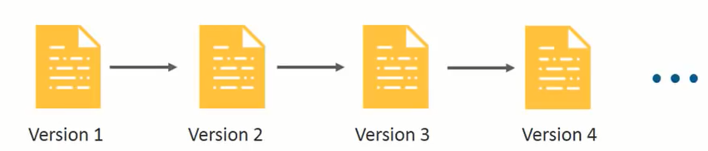

* Every commit has been stored in versions wise as shown in above figure.

# **Basic Commands in Git:**

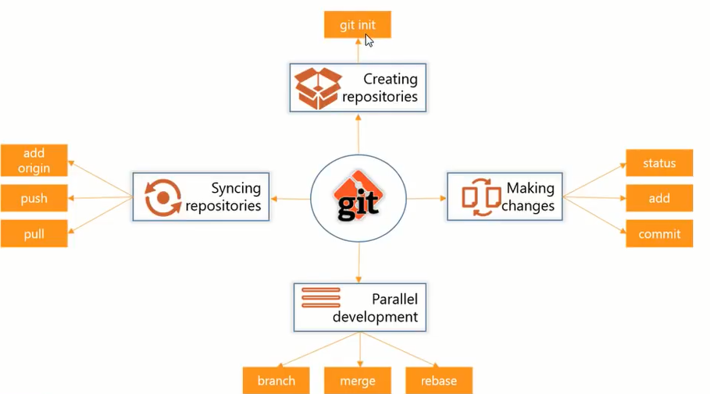

## **First Time Git Configuration**

Before you can start using Git, you need to configure it. Run each of the following lines on the command line to make sure everything is set up.

***# sets up Git with your name***  
**git config --global user.name "<Your-Full-Name>"**  
  
***# sets up Git with your email***  
**git config --global user.email "<your-email-address>"**  
  
  
**git config --list**

* For creating local repository(initializing the git in our local folder) by using

**git init**

* Their is in existing repository in github(Remote repository) we need to clone that by using

**git add remote url(**[**https://github/swamykankipati**](https://github.com/swamykankipati/Web-Design-Online)**)**

* **After** cloning u will get your github repository into your cloning path,then u need to add(**staging**) the files by using following commands.

**git add ram.txt (or).jpg(or)any file extention for single file.**

**git add <file1> <file2> … <fileN>**

**git add .**

This command:

* takes a space-separated list of file names.
* alternatively, the period . can be used in place of a list of files to tell Git to add the current directory (and all nested files)

**git add --a (or)git add --all for adding all files.**

* **I**f u need to remove(**unstage)**the staged files by using following command.
* **A**fter adding all files u need to check the files either it added or not by using the following command.

**git status(if u get green color then it is added)**

**(if u get red color then u need to add those files.)**

* **A**fter adding all files u need to commit the all the staged files by using following commands.

**git commit -am “our message”**( # unique message for each

commit.)

* After commiting completed you need to push the entair code into your Github Repository(global repository)by using following command.

**git push origin master(G**ive your credentials and get code on github)